CCLab midterm documentation blog

My name is Joyce and my project name is **Mazarine:** an phototropic alien backterium. Here you can see a petri disc with the dark grey soil sample from the alien planet and an creature seems like a bacterium living on it. Move the position of the light source and put some cultivated cells seperated from the creature by moving and clicking your mouse respectively to make further observation.

The space exploration team accidentally landed on a wrong planet on their way to a task. For safety reasons, they decided to let the engine cool down before restarting it. So some team members decided to take this time to walk around to briefly know about this world. The days here are very short and the nights are very long. The members used torches, when suddenly they found something very small “sparking” and moving towards them slowly. Also, the light of the torch seemed to leave “a mark” on the ground where it had shone. Due to the time limit,the team members were unable to seek other creatures, hence they just collect some samples of the soil there and take that small creature back. There are still a lot of unanswered questions about it and please don't worry. I have asked the explorers to brought me more samples.

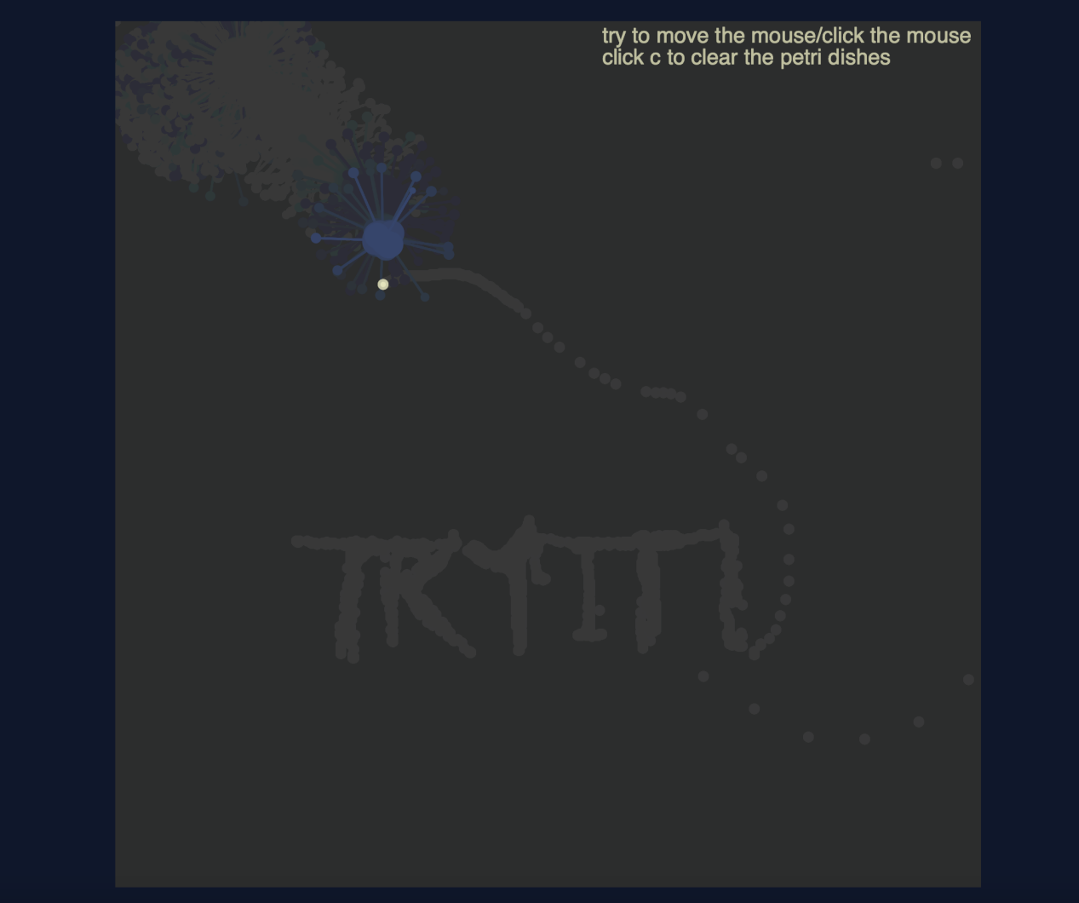

1) Process: Design and Composition

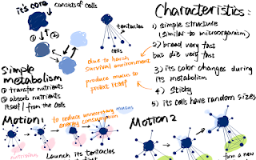

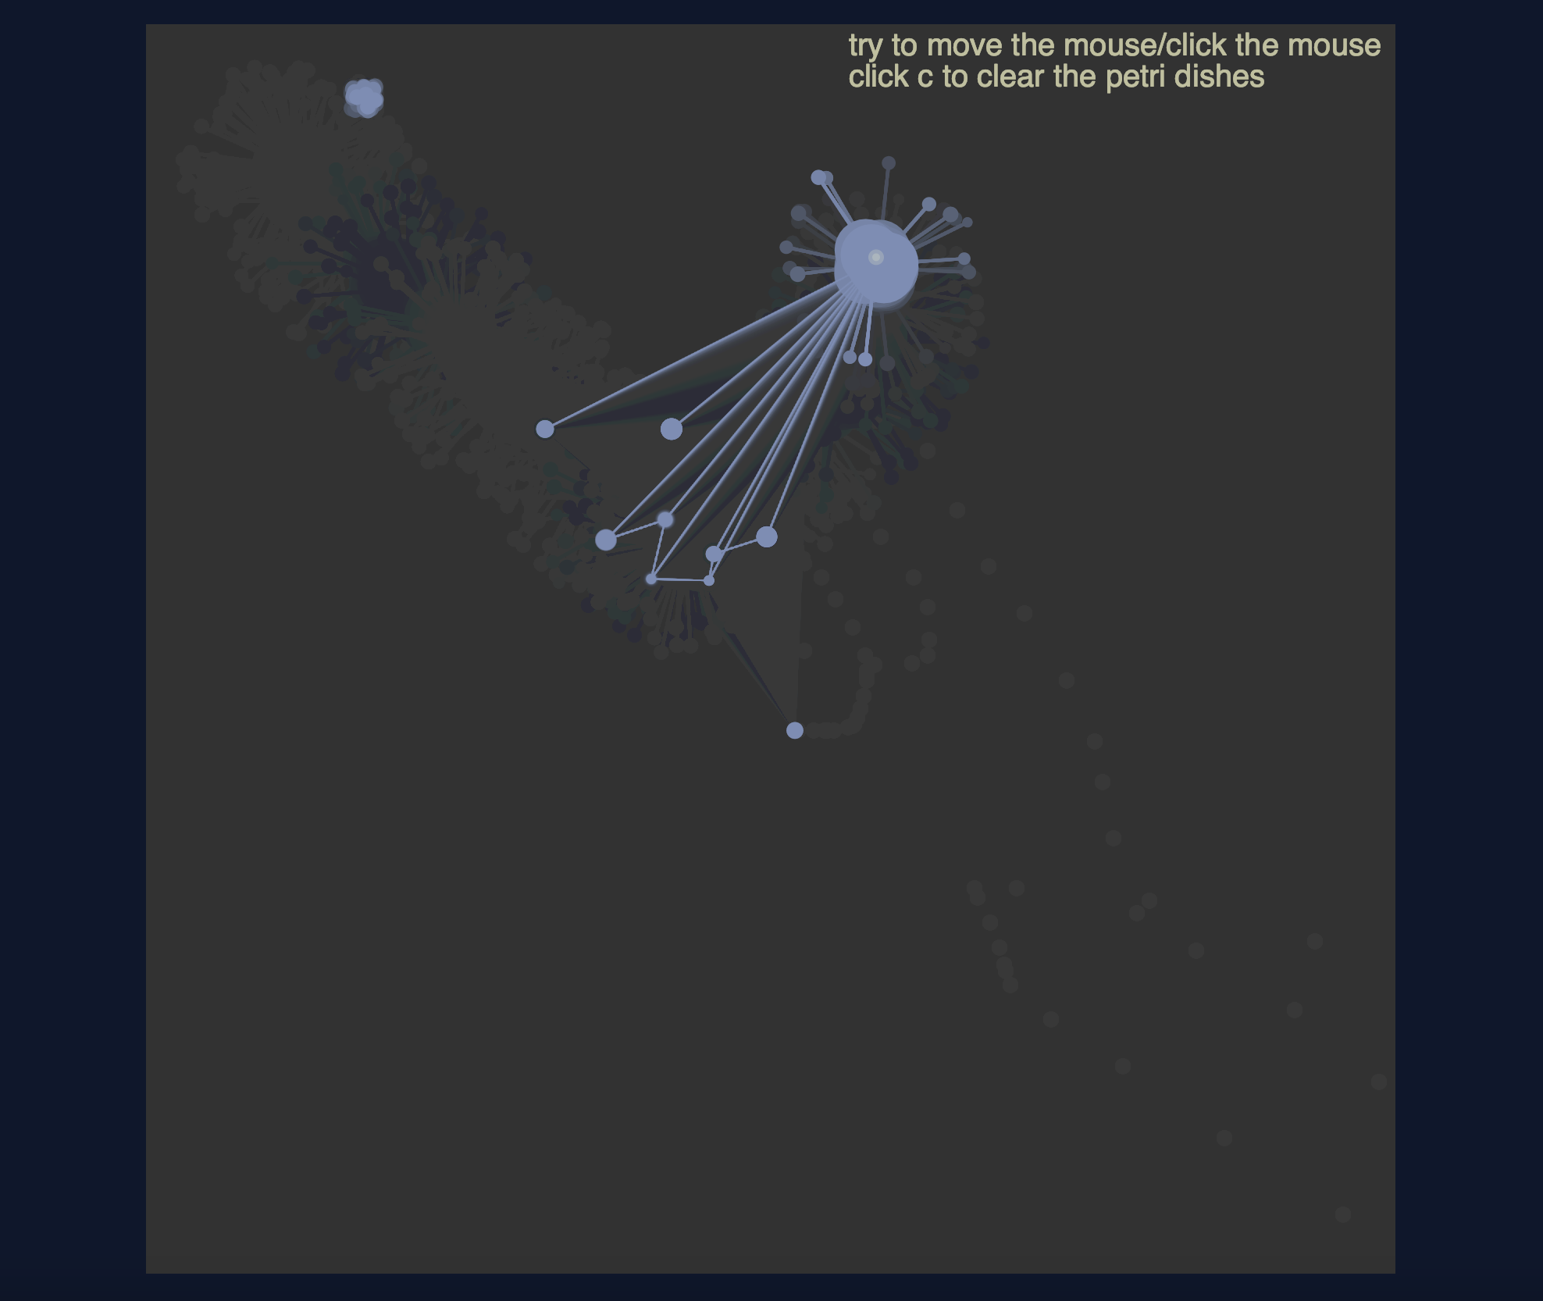

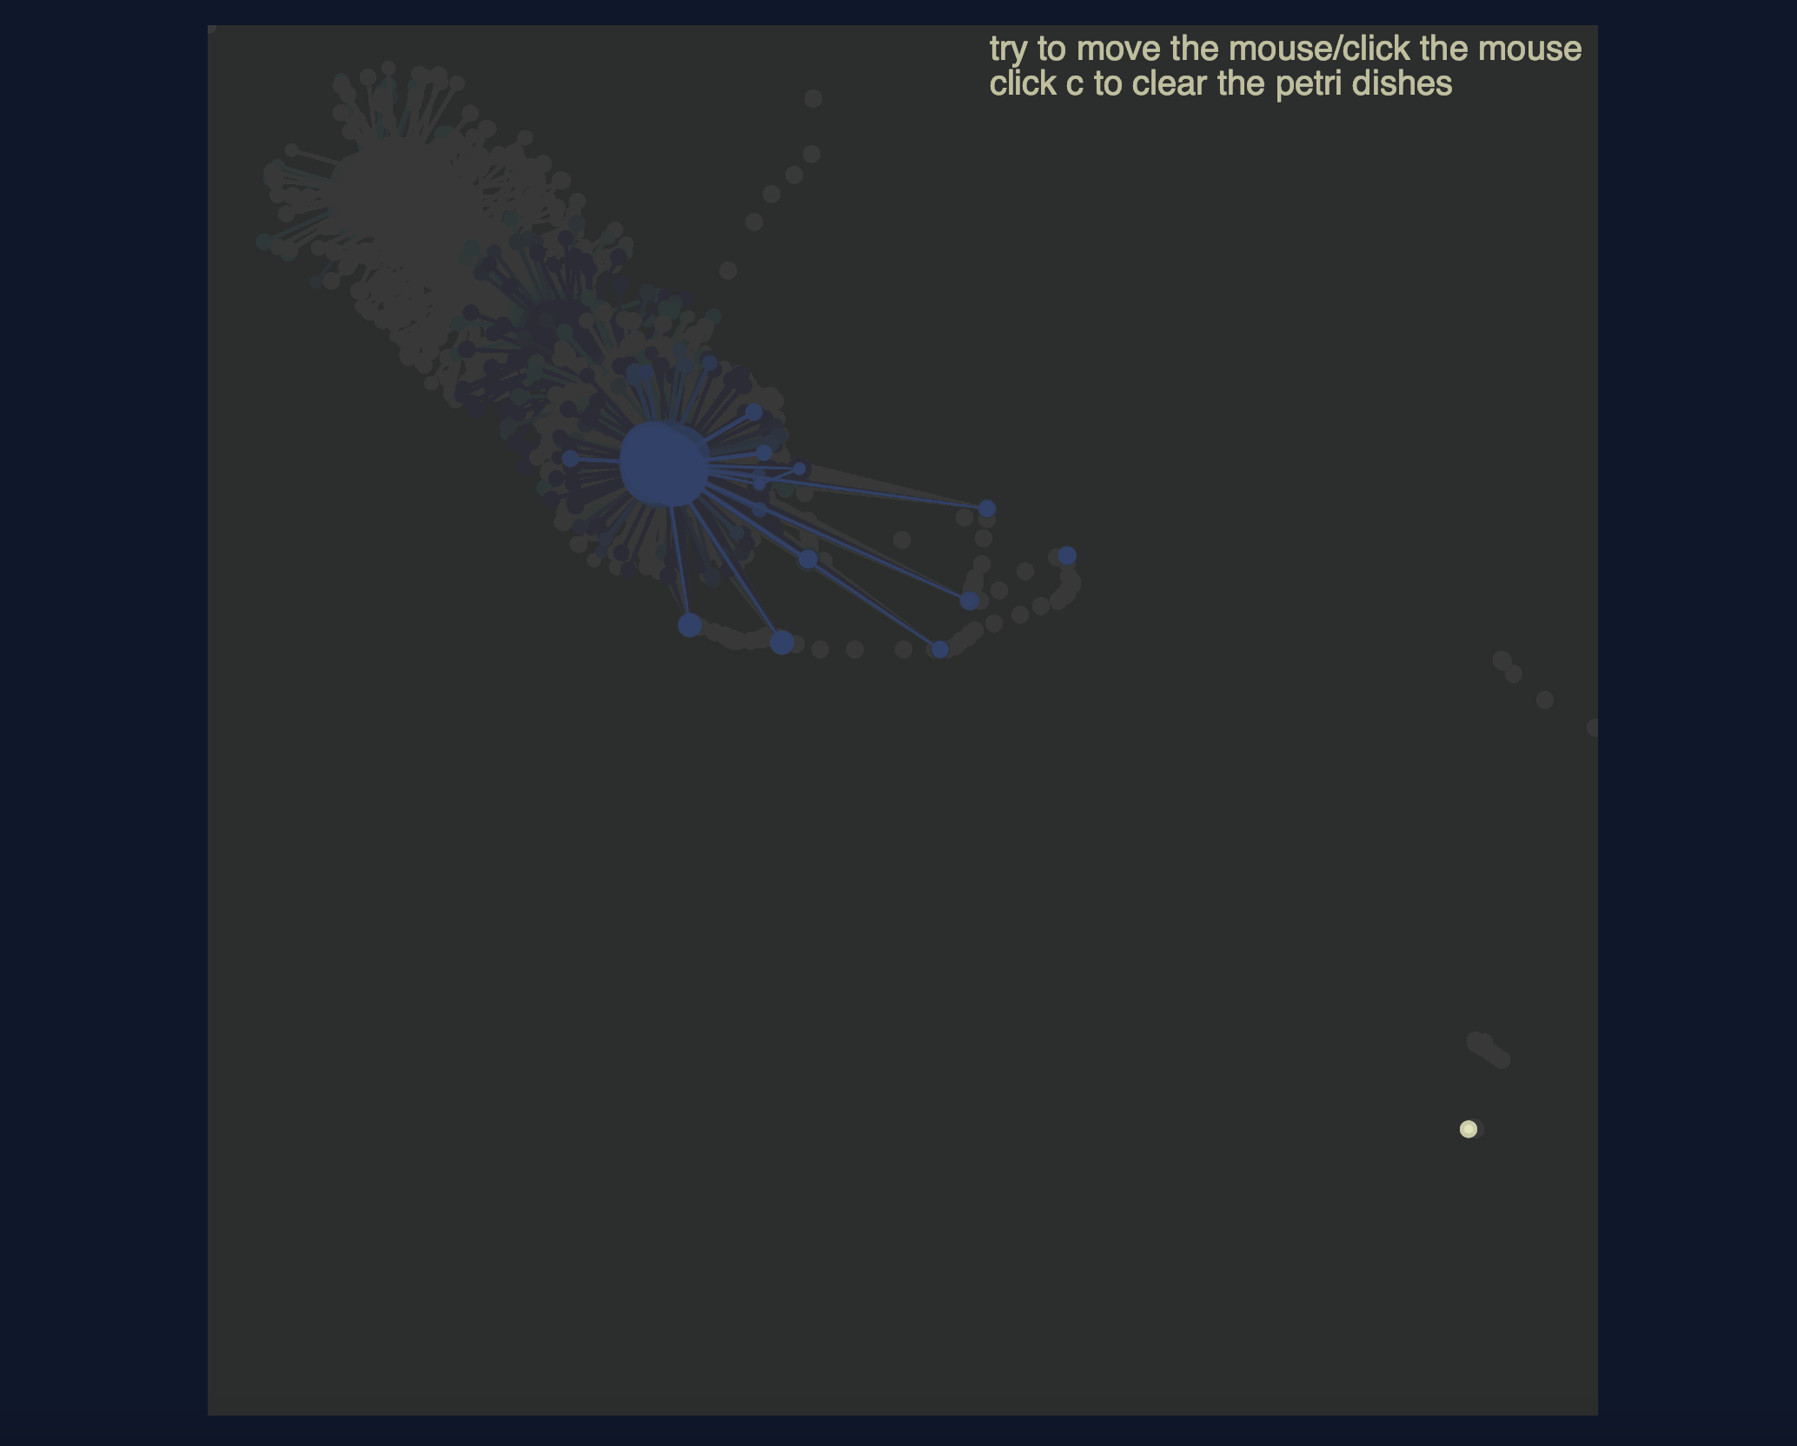

Here is the first version of my design. And my second version is the [project now. What don’t change are the change of the brightness of the color, the change of its core’s shape and size, the change of cells’ sizes, and its radomly generated tentacles. Also, when the creature isn’t interacting with the user, it is set to move like a random walker. They are all intended to make the creature looks more lively and looks more like a form of life.

What is different is the interaction part. I finish it with mainly if() and arrays.At first, I scheduled to have the creature’s direction of movement depend on the number of cells viewer’s put on the canvas. However, due to my limited knowledge about arrays, I failed to reach this target. So I decided to have the creature follow the mouse, and make the creature have a sensing range: if the cell or the light source(mouse) is too far away from it, it wouldn’t make connection with the cells or would stop moving. Additionally, in order to make the creature more like a form of life, I decide not to use mouseX and mouseY as the creature would need time to react and is more likely to move at a stable rate.

I think these changes, though may be simpler than I originally designed, make more sense in stories and is more interactive.

1. Process: Technical

I first build the core part of the creature, then the tentacles, then the interaction part. From simple ones to complex ones, building the major part first, then add more details.

Compromises and discoveries:The first difficulty I encountered is the cells which I mentioned in part (1). The second one is that I would like to make connections between the cells users put on the canvas. However, this means to select parts of the elements of the arrays and I failed to do that, so I compromise to only make connections with the one put before it if they are close enough. The third one is the baby it reproduced. I failed to make the baby more complex in stage 2 as I can’t cut the interaction with the mazarine and the canvas would looks very messy. I then only maintain the movement interaction with the baby. The forth one: the background. I tried to make it looks more textured by using for() to create many small circles, but the effect is not that good(looks messy). so I use a simple color.

Solutions and discoveries:The creature’s tentacles randomly appears in a ring-shaped range by using sin( ) and cos(). Secondly, instead of mouseX mouseY, I managed to use if() to make the creature follow the mouse to move slowly. Thirdly, I learned to set variables( mode() ) to create different stages of the project, managed to have a baby maintained on the canvas. Those solutions largely motivated me to improve further.

I think at least the baby can be more interactive by increasing its body size to the same one as the mazarine. I would try to add an if() to see if it works. Also, maybe I should add more details to the background to make it looks more like soil.

3) Reflection and Future Development

conclusions:(simplified)

What I am able to achieve and learn:

1Become more proficient in the use of translate()、arrays

2How to make my coding looks more tidy and simple to understand/to check : by using functions and //instructions

3The use of dist() ; learn to set variables to create different stages of the project

What I struggled with:

1The creature’s tentacles randomly appears in a range whose shape is circle

2The interaction part: put the cells and the connection with each other and the main body

3Instead of mouseX mouseY, how to make the creature follow the mouse to move

4A good background

suggestions gained from classmates in the first interaction day:

a better background color(at that time my background was dark red)

make the creature’s movement more interactive( at that time my creature can’t follow the mouse)

suggestions gained from the presentation:

I can use createGraphic() to try to tackle the problem of the background. Also, add more interaction with the baby like changing its size and color. Besides, add more interactive like press the key to provide some food. Moreover, there may exist some bugs in the sensing range. Last but not least, it can reproduce more

I would like to strive to turn all the suggestions into reality and make my project more complete. The users can not only explore and observe the mazarine but also its reproduction’s growth. I would like to explore how to have the mazarine generate more reproductions which can also grow and interact with the cells without creating many many new stages of the project